**Low-Level Architecture and Data Models**

**P02:BaechDay.com**

**<team member names & ids>**

|  |  |
| --- | --- |
| **Student ID** | **Name** |
| **23100181** | **Nashit Iftikhar** |
| **23100225** | **Muhammad Arsalan Ullah Tarar** |
| **23100157** | **Moiz Nafey** |
| **23100089** | **Mahad Mubashir Beg** |
| **23100334** | **Silal Anwar** |

|  |  |  |
| --- | --- | --- |
| **Content** | **Totals** | **Obtained** |
| Architecture diagram | 30 | 25 |
| Architecture justification | 20 | 10/0 |
| E/R diagram | 30 | 20 |
| E/R diagram description | 20 | 10 |
| Late submission |  |  |
| **Total** | **100** | **Plagiarism check** |
| **Individual Evaluation** |  |  |
|  |  |  |
|  |  |  |
|  |  |  |

**Table of Contents**

1. Introduction 3

2. System Architecture 4

2.1 Architecture Diagram—As it is in the prototype code 4

2.2 Architecture Diagram—As it should-be 4

3. Data Models 5

4. Tools and Technologies 6

5. Who Did What? 7

6. Review checklist 7

# Introduction

Pakistan is a huge country with a population numbering in the millions, yet the GDP of Pakistan remains rather low as compared to its massive population. We aim to facilitate the people of Pakistan by presenting our auction system. Our software will allow people to auction off their belongings to interested parties. Currently there exists no such platform that supports auctioning as a mechanism. In the status quo, people must spend valuable time and effort searching for customers to purchase their goods at a decent price. We aim to bridge this divide and bring value to the economy of Pakistan by solving this problem. This software will target both businesses and individuals in the Pakistani context. Small scale businesses currently do not have a platform to bid for resources, and shipments. A small scale mobile phone retailer finds it very inconvenient to currently bid for a shipment of mobile phones and similarly, repair shops face the same issue with car spare parts. Our auction system will allow wholesalers to enter their products for retail vendors to bid on. This has the potential to facilitate both wholesalers and the retail industry of Pakistan. Likewise, on a more individual scale, people with valuable assets are unable to put up their goods for the best price and must sell at the highest customer they manage to find. Our model will allow these users to list their belongings and allow bidding on it for the user to find the best price they can get from their belongings. Our software will function similar to an ecommerce marketplace but with the added functionalities of timed biddings, scheduling of bids and other functionalities that will make the auction system a good and worthwhile experience for the users we target.

# System Architecture

## Architecture Diagram—As it is in the prototype code

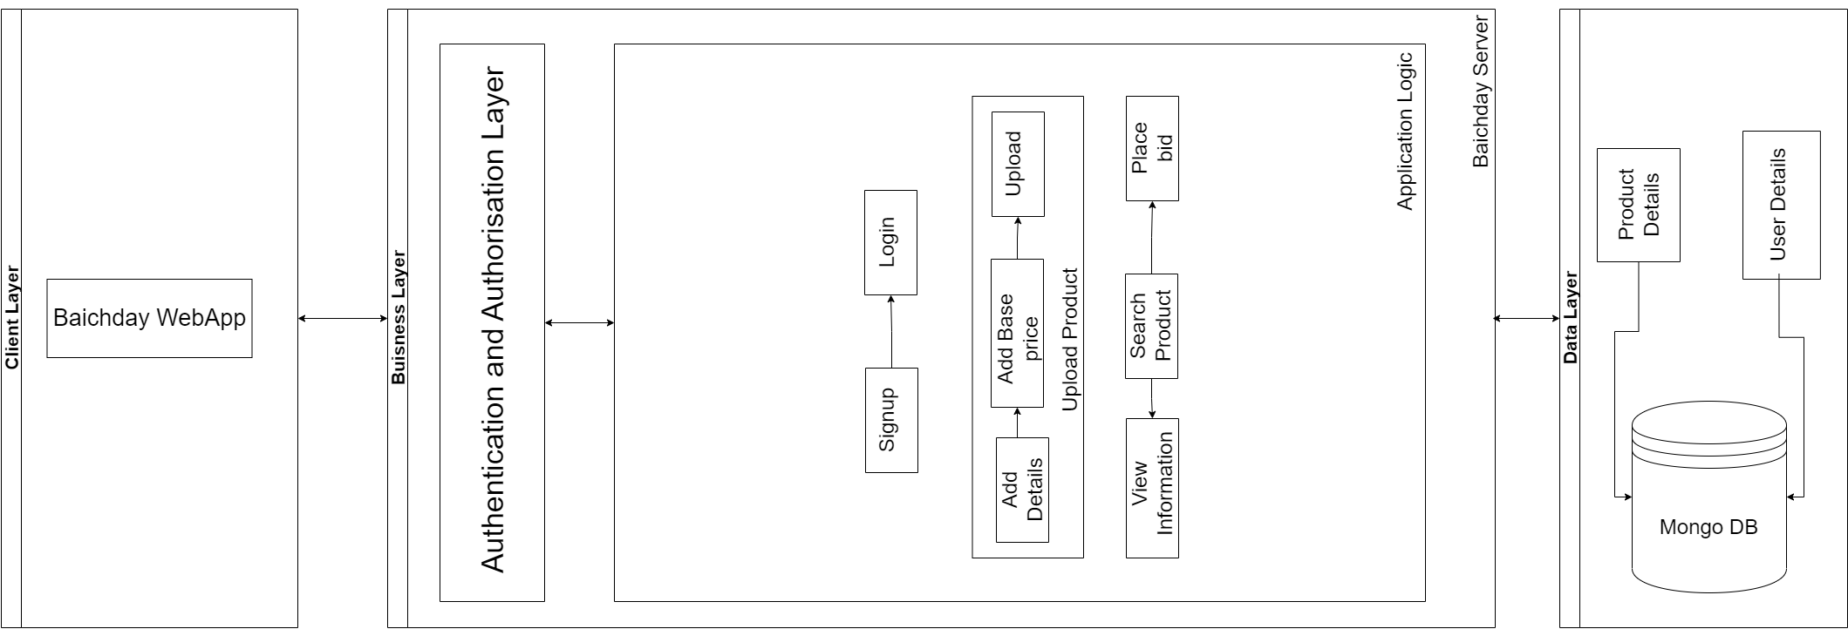

## Architecture Diagram—As it should-be

[You should also add subcomponents in the client layer. ]

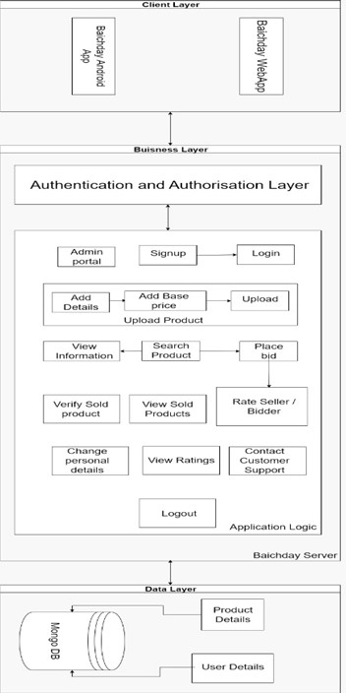

[You content below are in most part similar to content in a document submitted by another group. This appears to be plagiarism.]

Our system consists of a three-tier layered architecture solution comprising of the following layers:

1. **Client Layer:** The Client layer consists of all the interfaces for users’ interaction with the system. It consists of our BaichDay webapp portal and the BaichDay android app. The client layer is dependent upon the Business layer and will communicate with it through REST APIs and message system.
2. **Business Layer:** The business layer consists of two sub layers:  
    a. The Authentication and Authorization layer will contain the logic to authenticate requests from the client layer as well as grant access rights to the clients.  
    b. The application logic layer will contain the logic for the use cases of the application such as uploading a product, placing a bid etc.  
    The business layer will act as a bridge between the data layer and the client layer. The business layer will be responsible for all sorts of validation and verification. Furthermore, it will be responsible for reading data from and writing data to the data layer.
3. **Data Layer:** The data layer will store all data related to the system in a MongoDB database. The data layer will only be able to communicate with the business layer directly.

**Maintainability:**

The monolithic architecture [Monolithic architecture is not good from maintainability perspective. Why do you think that your system architecture is monolithic?] will allow us to carry out deployments at a faster rate and will make testing easier for all the stakeholders. It allows easier error tracing and positively affects the trust between the components of the system. Hence making the system more maintainable.

[You need to review reusability and extensibility. I would suggest read definitions of reusability and extensibility and then update this section.]

**Reusability:**

The communication within the internal components of the system will be easy to understand and make the architecture easier to reuse.

**Extensibility:**

The usage of the pipes and filtered architecture within the business layer will allow us to introduce new and improved features with the ease of ensuring the scalability of the system.

**Separation of concerns:**

The layered architecture allows replacement of the entire layer without having any negative repercussions for the rest of the layers if the interfaces of all the layers remain intact. This allows each layer to remain scalable individually. In order to accommodate changes (including changes in interfaces) in one layer, only the adjacent layers will need to be adapted.

# Data Models

[There should be other entities such as history, different type of users and their access rights etc. ]

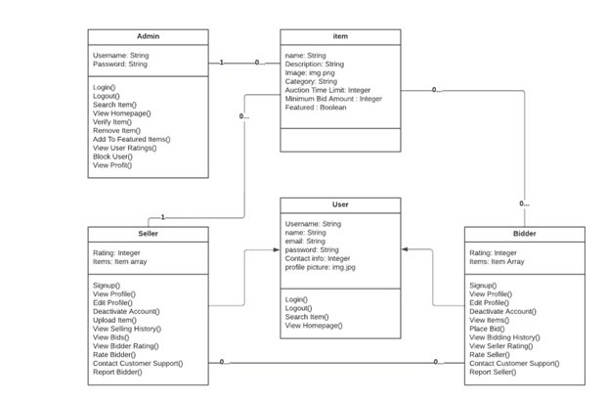

Item: Contains details about item listed on the BaichDay page such as name, images and bids etc

Admin: Can control access for users and control items, verify items and users etc

User: can be a bidder or seller upload product or place a bid on other products. Customers of the business.

[Give comprehensive description of each entity.]

# Tools and Technologies

|  |  |  |
| --- | --- | --- |
| **Sr.** | **Tools & Technologies** | **Description** |
| 1. | Visual Studio Code | Visual Studio Code is a simplified code editor used for debugging, code implementation, and version control. It gives developers the tools they require for a fast cycle of code-build-debugging and supports more sophisticated processes and features to the Visual Studio IDE.  [Version 1.72](https://code.visualstudio.com/updates)  <https://code.visualstudio.com/> |
| 2. | Postman | Postman is an API platform for building and using APIs. Postman simplifies each step of the API lifecycle and streamlines collaboration so you can create better APIs—faster.  The Postman platform includes a comprehensive set of tools that help accelerate the API lifecycle—from design, testing, documentation, and mocking to the sharing and discoverability of your APIs  Postman’s full-lifecycle approach to governance lets adopters shift left their development practices, resulting in better-quality APIs, and fostering collaboration between developer teams and API design teams.  [Version 9.4](https://learning.postman.com/docs/getting-started/installation-and-updates/)  <https://www.postman.com/> |
| 3. | MongoDb Cluster | MongoDB is a source-available cross-platform document-oriented database program. Classified as a NoSQL database program, MongoDB uses JSON-like documents with optional schemas. MongoDB is developed by MongoDB Inc. and licensed under the Server Side Public License which is deemed non-free by several distributions.  [MongoDB 6.0](https://www.mongodb.com/new)  <https://www.mongodb.com/home> |
| 4. | React JS | React is a front-end JavaScript toolkit that is free and open-source for creating user interfaces based on UI components. It is kept up-to-date by Meta and a group of independent programmers and businesses.  Version 17.0.2  <https://reactjs.org/> |
| 5. | Heroku | Heroku is a cloud platform as a service supporting several programming languages. One of the first cloud platforms, Heroku has been in development since June 2007, when it supported only the Ruby programming language, but now supports Java, Node.js, Scala, Clojure, Python, PHP, and Go.  <https://www.heroku.com/> |

# 

# Who Did What?

|  |  |
| --- | --- |
| **Name of the Team Member** | **Tasks done** |
| Nashit Iftikhar | Complete document |
|  |  |
|  |  |
|  |  |

# Review checklist

Before submission of this deliverable, the team must perform an internal review. Each team member will review one or more sections of the deliverable.

|  |  |
| --- | --- |
| **Section** **Title** | **Reviewer Name(s)** |
| Arsalan Tarrar | Tools and Technologies |
| Silal Anwar | Architecture |
| Mahad Mubashir | Data Models |
| Moiz Nafay | Introduction |